A CRITICAL LOOK AT KUMASI IN THE LENSE OF HERITAGE, LAND GOVERNANCE, RESILIENCE, AND SUSTAINABILITY 20211906
I. Introduction
Kumasi, similar to other developing is experiencing rapid population growth (Abass et al., 2019). This phenomenon has also led to rapid urban development that disregards the significance of resilience, and sustainability as its growth fails to encompass all the significant aspects of a city. ‘Kumasi is the second-largest city in Ghana’ and is located in a 270km radius as a result of its rapid population growth, the spatial development pattern of the city has expanded nearly two times the rate of the city’s population growth. The resultant effect of the city’s unplanned growth is slum proliferation, urban sprawl, housing challenges (Adu-Gyamfi et al., 2022; Asibey et al., 2021), a boom in unregulated informal economic activities (Asibey et al., 2021), depletion of green spaces (C. Amoako & Adom Asamoah, 2017; Narh et al., 2020) and traffic congestion (Obiri-Yeboah et al., 2021).
This paper, therefore, seeks to conduct a review of the theories of heritage, land governance, urban complexity, resilience, and sustainability, analyze Kumasi in the light of the theories, and recommend a pathway forward. Specifically, this paper will realize these objectives: I. To conduct a review of Resilience, and Sustainability. II. To review Kumasi in light of the previously mentioned theories. III. Conclude and give recommendations on a future pathway.
II. Review of Resilience, and Sustainability
i. Resilience
By 2030, it is expected that there will be nearly two billion more people living in cities than there are now. Climate change and unplanned urbanization continue to be two significant environmental and health challenges with far-reaching consequences for developing countries. (Rhoda Mensah Darkwah et al., 2018).
In this regard, numerous concerns and obstacles have hampered the urban environment, including, but not limited to, inadequate infrastructure, incorrect design to support population increase, and insufficient services. (Feyzio, 2022). Since the late 1990s (Mileti, 1999), when the term "resilience" was first used in urban planning, it has become a major focus of research and policy in urban planning practice and in the subject of urban studies, commonly referred to as "sustainable urban development"
or "sustainable development." (Brand & Jax, 2007; Davoudi et al., 2012; Perrings, 2006; Woolf & Joubert, 2013).
Resilience as defined by Cobbinah & Darkwah, (2016) is a process and the ability to come out or bounce back from serious social, environmental and economic challenges.
The term "resilience" was used to describe how environmental systems deal with the hazards they face and how they deal with the effects of change (Holling, 1973). Urban resilience (UR) is a key concept in preparing cities for crises and unforeseen circumstances caused by climate change-induced extreme weather conditions. It is also defined as a system's ability to respond to unexpected events, risks, and changes by either preventing or minimizing the effects of these events (Feyzio, 2022). African countries as the most vulnerable to climate change and the least prepared in the world (Washington Post, 2019). Cities in Ghana are becoming increasingly vulnerable to the effects of climate change and unplanned urbanization. (Rhoda Mensah Darkwah et al., 2018)
In this period of high urban population increase and severe climate change impacts, consensus shows that the urban resilience concept, when used, is an acceptable approach for successful and efficient city administration, particularly in developing nations (Asibey et al., 2021). Due to its basic principles of building adaptable and enduring urban environments, the established urban resilience ideology, emphasizing sustainable development and effective management over traditional adhoc responsive approaches to urban planning in Africa, has resulted in the re- cognition of urban resilience as a new planning ideology (Darkwah et al., 2018). According to the literature on urban resilience, unlocking socioeconomic and environmental options for city dwellers is critical to urban resilience (Chelleri & Olazabal, 2012; UNISDR, 2013). However, urban resilience's contribution to improving and establishing a sustainable and adaptable urban environment in Kumasi has been restricted due to a lack of attention by planning related authorities on delivering benefits to urban people, particularly those living in the most vulnerable communities.
ii. Sustainability
Sustainable development, from its nominal connotation could be taken to mean indefinite development. And that will neither be wrong nor far from the technical definitions of the concept. Like many other terms and concepts, its definition is constantly being revisited by politicians,
researchers and all whom basically care. To define sustainable development, one can look for the separate meanings of both words that are “sustainable” and “development’. Unlike “Sustainability”, “development” has been highly contended and rigorously and differently defined by several authors and even governments. With an ever-evolving definition, one could be tempted to believe that the definition of the word is geographically and time-sensitive. At one time in the timeline of the development of the understanding of the word, it was taken to mean economic growth and at another, the upward movement of social factors. In however and wherever understood, development is a desired change. The introduction of the word “sustainability” into the development discourse (an already contested word) was in itself a paradigm shift. ‘Sustainable development was given worldwide attention by the Brundtland Commission Report in 1987 which asserts that development is sustainable if it meets the needs of today without jeopardizing the ability of future populations to meet their own needs’ (World Commission on Environment and Development, 1987) . Sustainable development is a development process which has no negative effect on the environment and takes into concern the need of the present and future generations (MLGRD, 2012). It is an integrative approach to development and in such a way that there are multisector and transgenerational benefits (Strange & Bayley, 2008). However, defined, one thing which is very important in the sustainable development literature yet remains obscurely said is that sustainable development is an object of the end of development and not the process of development. It focuses on the outcomes of development and their rippling effect. Another aspect that remains central to sustainable development and are sometimes referred to as the principles of sustainable development are the economic, social and environmental factors of sustainable development. They are the drivers of the concept and insist that developments are sustainable when they ensure the integration and endurance of existing social, economic and environmental factors. In much basic terms, sustainable development is making sure that society, the economy and the environment are not casualties of development but rather the center stage that is developed either directly or indirectly by development strategies and actions. Although a highly recommended development concept, the realities of sustainable development particularly its achievement in Africa has not been profound. Studies have shown that the strive for sustainable development has been fiercely threatened by the rapid urbanization of the continent (P. Cobbinah et al., 2015).
III. A case study of Kumasi
i. Overview and Heritage of Kumasi
The city of Kumasi was founded in the 1680’s by King Osei Tutu I to serve as a capital of the Asante State (Clifford Amoako, 2014). In regard to its strategic location and political dominance, Kumasi as a matter of course, developed into a major commercial center with all major trade route converging on it (Clifford Amoako & Adom-Asamoah, 2019). However, it became a colony of the British in 1890, it experienced massive expansion and growth due to its central location and pivotal role thereby making it second only to Accra in terms of, population size, and socioeconomic activities (Diko & Hollstein, 2021).
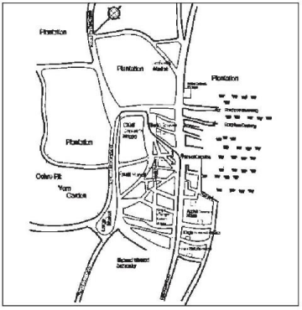Figure 1: The town of Kumasi 1817
Source: (Bowdich, 1819)
Kumasi was selected at the capital and seat of the Otumfour, the British Colonial Government held political power in Accra but restored the traditional council of the Ashanti to conduct the traditional affairs of the kingdom (Adu-Boahen. 1971).
Originally, Kumasi comprised of Adum, Krobo and Bamtama, but now grown to encompass about ninety suburbs, of which many came together as a result of growth process and physical expansion.
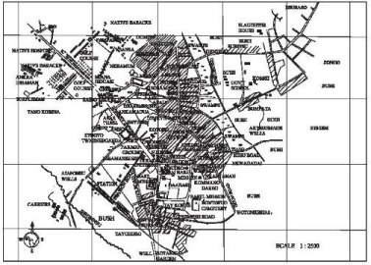Figure: Kumasi Survey Plan (1910) Showing Old Native District
Source: Town and Country Planning Department, KMA & (Clifford Amoako, 2014)
The Metro city Kumasi is now one of the most populous city in the country, and serves as a strategic location for trade and commerce acting as a principal inland transit point, thus making it a key center in the vast and profitable business of goods distribution in Ghana and exporting and importing to and from other West African countries such as Niger, Burkina Faso, Togo and Mali. The Kumasi metropolis serves as a central place to the country and other West African countries due to its location and its history.
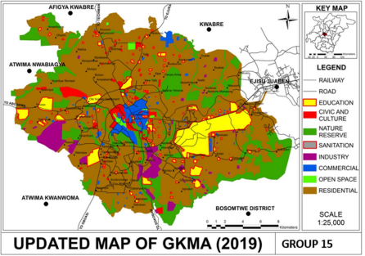KKFigure 1: Updated Map of Kumasi
Source: Authors’ Construct
Kumasi remains Ghana's cultural capital, though it has lost a good deal of its earlier glory. The once famous Cultural Centre, with a reputation well beyond the national borders, now shows only glimpses of its cultural superiority. The unique culture is manifested at the key stages of the life cycle - such as child naming, festivals, marriage and funerals. One can also mention the attempt at traditional music, dance and dirges at such gatherings as some of the traces left of Kumasi's cultural heritage.
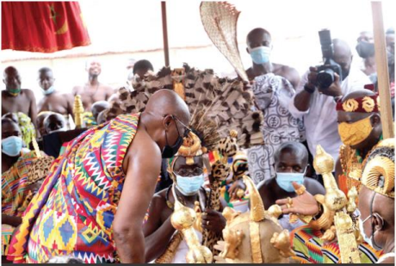Figure 1: Otumfuo Osei Tutu II and President Akuffo Addo at Akwasidae
Source: (Peace Fm Online, 2019)
These festivals are organized to remember specific events in history and also get the natives attached to the place of belonging. The rich display of culture colorful clothes and gold to represent the uniqueness of the Ashanti Kingdom. Other reasons for the festivals is also to promote tourism and boost the local economy.
Buildings such as the traditional buildings held by the UNESCO as part of the world heritage sites, these building are located (Abirim, Asawase, Asenemaso, Bodwease, Ejisu Besease, Adarko Jachie, Edwenase, Kentinkrono, Patakro and Saaman) at north-east of Kumasi, and Patakro, to the south these buildings were put up in the 18th Century (UNESCO, 1980).
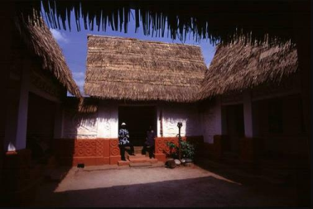Figure: Ashanti traditional building
Source: (UNESCO, 1980)
One of the very last symbols that represents the unique architectural style of the Asante Kingdom and its traditional motifs of rich bas-relief designs with signs on the walls (UNESCO, 1980).
ii. Land governance in Kumasi
In Kumasi, land tenure is grouped in two categories, customary land ownership and state land ownership, the cities rich cultural heritage reflects its tenure system (Clifford Amoako & Adom Asamoah, 2019). All the lands in Kumasi are primarily customarily held under the Asantehene and its commonly referred to as stool lands. For proper management, there are various sub chiefs for the various communities in Kumasi and from that end is land administered, the chiefs act as representatives of the Asantehene in the various communities.
Research e.g. Cobbinah et al., (2020) revealed, individuals seeking to buy a piece of land for a project(putting up commercial or residential building) first of all need to see the sunchief in charge of the area he/she wants acquire the land, negotiate and agree on an acceptable price(commonly called ‘drink money’). Upon agreeing on the sum to be paid, the sub chief will issue an allocation note the individual which he/she will submit to Asantehene Land Secretariat at Manhyia(Palace of the Asante King) from where enquires regarding the title vacancy of the land are made on collaboration with the
Lands Commission. After all the checks are done, the land title will be registered in the name of the prospective buyer; the Region’s land commission is responsible for land registration and preparation of the lease document. In spite of the dominance of the Ashanti King in land governance, the state also holds certain portions of lands allocated for public interest, lands allocated for the Komfo Anokye Teaching Hospital, Kwame Nkrumah University of Science and Technology, Kumasi International Airport and other lands across the city.
Due to the flaws that have sprung up over the years on the role of chiefs in the sale of lands allocated for green spaces and environmentally sensitive lands, public opinion on the significance of the traditional authority in Kumasi equitable land governance and sustainable development is divided. ‘An important consideration going forward is to consider the complementary roles of both the chiefs and the city planning authorities in relation to land use planning in Ghana’ (P. B. Cobbinah et al., 2020a). The goal is to marry tradition with professionalism to advance the sustainable development agenda.
iii. Resilience
In this paper, resilience in Kumasi will be looked at with two lenses on the institutional front and the policy front. Based on the nine tenets of urban resilience, urban planning experts in the various institutions were identified as having limited understanding of urban resilience. According to (Rhoda Mensah Darkwah et al., 2018), public officials responsible for institutions charged for ensure urban resilience were further interviewed and encouraged to expand on their understanding of urban resilience and the nine tenets, shocking reveal was the limited knowledge the concept.
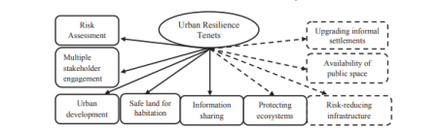Figure 1: Tenets of Urban Resilience
Source: (Rhoda Mensah Darkwah et al., 2018)
With evidence of the excess unplanned urban expansion issues in Kumasi, one would believe that institutions would be working on a comprehensive policy that makes a considerable effort towards effectuating the tenets of urban resilience concept. Research on urban resilience suggests that attaining socioeconomic and environmental opportunities for urban residents is central to urban resilience (Chelleri & Olazabal, 2012). With evidence from (Rhoda Mensah Darkwah et al., 2018) no evidence in form of policy is in place to contribute to the attainment of urban resilience with the core aim of developing a sustainable and adaptable urban space in Kumasi.
iv. Sustainability
Sustainable development can be defined as a notion that seek to satisfy current needs without jeopardizing future generations' opportunity to meet their own (Ramsden, 2010) .The concept has been adopted and employed by many countries with focus on enhancing and developing the lives on its indigenes. Ghana, a modern democratic nation seeking to make lives better has also adopted this concept. One of the cities in Ghana, Kumasi, is the focus of this review. It is the Ashanti Region’s administrative capital and the second largest city of Ghana. The historic Asante Kingdom, which was founded in the late 17th century, is still headquartered in the city.
In the 1940s, it was dubbed the "Garden City of West Africa" because of its lush urban landscape (Cobbinah et al., 2020b). Cobbinah et al., (2020a) claim that the city is currently confronted with rapid urban growth, as evidenced by planning system distortions, contradictory governance regimes, and deteriorating infrastructure and services.
The city is however has undergone drastic changes and the concept of sustainability has become the mainstay of development discourse. It is faced with critical issues of global concern not limited to poverty, climate change, inequality and population growth. In terms of population expansion, high rise building are seen as a sustainable way of curbing and mitigating its effects (Agyemang et al., 2018). While many urban managers see the promotion of high-rise buildings as a path to sustainable development, Agyemang stated that the sustainability of such development, particularly in Kumasi metropolis, is in itself questionable, and that the pursuit to curtail urban expansion should not be sought blindly and haphazardly, as the likely abandonment of high-rise buildings due to their low social acceptability could be on the horizon. In the process of establishing high-rise structures, the study advocated improving the implementation of development control regulations and building particular codes.
Kumasi city has developed a budding commercial hub. It has an eco-friendly market centre which attracts shoppers widely not only from Greater Kumasi but also from other parts of the country and in west Africa. Depletion of urban green spaces in Kumasi continues to be a challenge (Adjei Mensah, 2016). However, efforts are being made the regenerate urban greenery (Ratray Park in Kumasi). In 2021, the government of Ghana embarked on nationwide tree planting exercise to enhance and promote urban greenery and ultimately promoting sustainability. To sum it up, sustainable development continuously seeks to achieve social, economic, and environmental progress. By working towards sustainable development we use the resources available to us judiciously in order to ensure the people of the future have access to it as well.
Conclusion
In conclusion urban complexity should be considered in urban planning since it is an important tool in urban planning. Even though Kumasi as a city has deficiencies in sustainability and reliability due to a wide range of factors nercua@ihs.nl

